James Dawson named 2014 Queen of Teen

The Young Adult author has been praised for his sensitive portrayal of gay teenagers
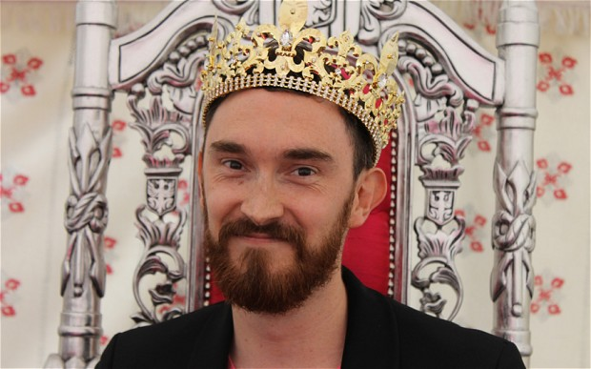
YA author James Dawson is crowned Queen of Teen Photo: The Book People
By Rebecca Hawkes
4:19PM BST 11 Jul 2014
James Dawson, the author of the Young Adult novels Cruel Summer, Hollow Pike and Say Her Name, has been named the 2014 Queen of Teen.
The Queen of Teen award was set up in 2008 to honour writers of teen fiction. The shortlisted authors are all nominated by teenage readers, who then vote for an overall winner. This year marks the first time a male author has been named as the winner.
Dawson's novels have been praised for their sensitive, down-to-earth portrayal of gay characters.
The author, a former school teacher, recently spoke out about how, when he was growing up, there was a lack of gay characters in fiction for teens to identify with, telling The Guardian: “I so dearly wish there had been just one book with a character who was a bit like me – just a normal teenage guy who happened to be gay. I would have especially loved one whose sexuality did not define him.”
READ: The top 10 YA books of 2013
The other novelists shortlisted for this year's award were The Fault in Our Stars author John Green, Veronica Roth (author of Divergent), Natasha Farrant, Cathy Cassidy, Sue Ransom, Beth Reekles, Holly Smale, Tonya Hurley and Cassandra Clare.
Clare, whose book The Mortal Instruments: City of Bones was adapted into a film last year, has also spoken out about the need for more gay relationships in children’s fiction, revealing that publishers initially turned down her book series, due to the fact that one of the main characters is gay.
Addressing an audience at this year’s Hay Festival, Clare said: “If publishers are throwing up roadblocks to wider representation of different parts of society, then we need to try harder to write books about them."
Previous winners of the Teen of Queen award include Maureen Johnson, Cathy Cassidy and Louise Rennison.

